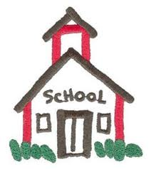
For 16 years, the Community Center of Northern Westchester has provided thousands of students with basic school supplies. Once again we are seeking donations of new items for students ages 3 to 18. This program eases the financial burden faced by many families at the beginning of the school year, and helps students get off to a great start in school! We begin handing out supplies in August.
SCHOOL SUPPLIES 2016

Preschool:
Crayola large crayons
Coloring book or pad

Elementary:
Crayola Washable Markers
Crayola crayons (box of 24)
Glue sticks
Colored pencils
#2 pencils (packages of 12)
Two-pocket folders
Black & white marble composition books
Handheld pencil sharpener
Erasers
3”x3” Post-Its
Soft nylon pencil bag
12” ruler (inches and metric units)

Secondary:
Colored pencils
#2 pencils (packages of 12)
1” 3-ring binders
Notebook filler paper
Subject dividers
Single-subject notebooks
Two-pocket plastic folders
Black & white marble composition books
3” x 5” white ruled index cards
3” x 3” Post-Its
Erasers
Soft nylon pencil bag

A donation of $25 will provide a student with basic supplies!

Donations may be brought to the Center at 84 Bedford Road in Katonah from 10:00 AM to 4:00 PM Tuesdays through Fridays and from 10:00 AM to 1:00 PM on Saturdays. If you would like to volunteer to help sort and pack school supplies, please contact the Center at (914)232-6572 or at
info@communitycenternw.org.

Visit our website for more information: www.communitycenternw.org

